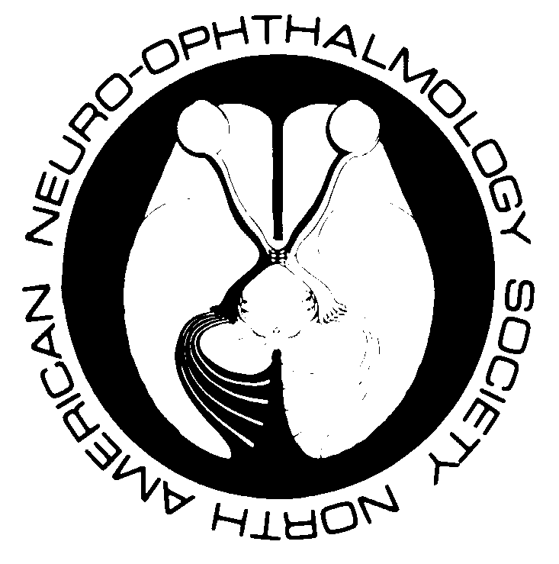
North American Neuro-Ophthalmology Society

Continuing Medical Education Verification

Total possible CME credits: up to 28.5 Tally Your Credits Here

Sunday, April 2 Frank B. Walsh Session ________ 6 credits
Monday, April 3 Journal Club ________ 2 credits
Monday, April 3 Hot Topics in OCT ________ 2 credits
Monday, April 3 Applications of Advanced Retinal Vascular Imaging in Neuro-Ophthalmology ________ 1.5 credits
Monday, April 3 Radiation Oncology for the Neuro-Ophthalmologist ________ 1.5 credits
Monday, April 3 Scientific Platform Presentations: Session I ________ 2 credits
Tuesday, April 4 Scientific Platform Presentations: Session II ________ 3.75 credits
Wednesday, April 5 Afferent and Efferent Rehabilitative Strategies in Neuro-Ophthalmology ________ 3.5 credits
Wednesday, April 5 Jacobson Lecture: Going with the Flow ________ .75 credit
Wednesday, April 5 My Baby can’t see! ________ 1.5 credits
Thursday, April 6 Neuro-Ophthalmologic Side Effects of More Recently Used Medications in
Treating Cancer, Rheumatologic Disorders, and Multiple Sclerosis ________ 2 credits
Thursday, April 6 Eye Movement Challenge: The Advance Level ________ 2 credits

TOTAL ________ 28.5 credits

TOTAL_34 credits______
To verify attendance, circle credits of programs attended. Maximum credits 34

I certify that I participated in the above CME live activity for _____ credits.

(Participant Signature)
*SELF-ASSESSMENT – ABO & ABPN approval of up to 30.5 self-assessment hours (includes pre/post-test hours)
THE AMERICAN BOARD OF PSYCHIATRY AND NEUROLOGY HAS REVIEWED THIS MEETING AND HAS APPROVED THIS PROGRAM AS PART OF A COMPREHENSIVE LIVE PROGRAM, WHICH IS MANDATED BY THE ABMS AS A NECESSARY COMPONENT OF MAINTENANCE OF CERTIFICATION.

This activity meets the Self-Assessment CME requirements defined by the American Board of Ophthalmology (ABO). Please be advised that the ABO is not an accrediting body for purposes of any CME program. ABO does not sponsor this or any outside activity, and ABO does not endorse any particular CME activity. Complete information regarding the ABO Self-Assessment CME Maintenance of Certification requirements are available at www.abop.org.

